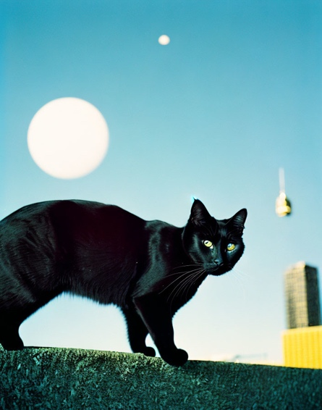Picture1

Prompt: A view of a black cat from behind. Some skyscraper in the back ground. Art by Salvador Dali.

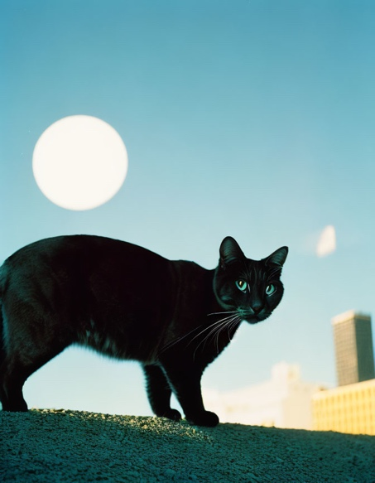Picture2

Add: Add more buildings in the background

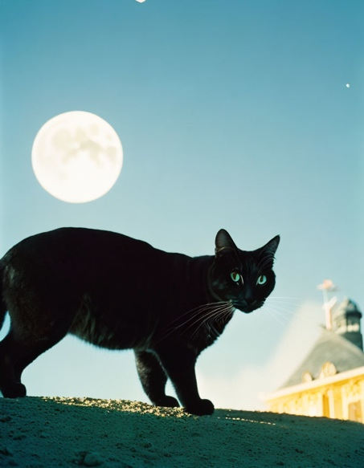Picture3

Adjust: Add more detail of the moon

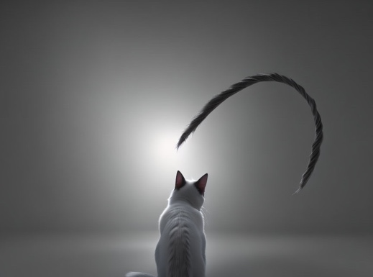pitcure4

Prompt: back view of a cat in the dark

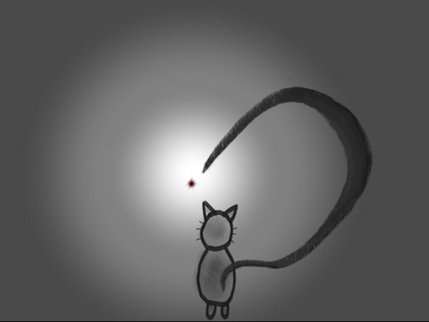

Base image